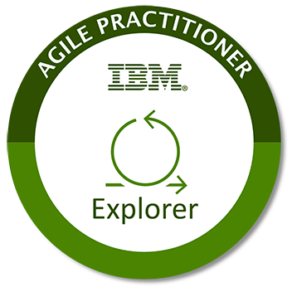

**IBM Agile Explorer Badge Checklist**

The Agile Explorer has a foundational understanding of Agile values, principles, and practices that allows them to initiate an Agile conversation with co-workers and colleagues.

**NOTE:** This is not the application. To submit your application please see the link at the bottom of the Explorer Landing Page:

**Education Criteria:**

* Completion of Agile Academy course – LT-3469 [Taste of Agile](https://agileacademy.mybluemix.net/courses/taste_of_agile) (approx. 110 min)
* Completion of Agile Academy course – LT-3563 [Agile Operations Fundamentals](https://agileacademy.mybluemix.net/courses/agile_operations_fundamentals) (approx. 80 min)
* Completion of Agile Academy course – LT-3538 [Agile Program Fundamentals](https://agileacademy.mybluemix.net/courses/agile_program_fundamentals) (approx. 80 min)

**Education Evidence:**

* Screen capture(s) from [Agile@IBM](https://agile-ibm.mybluemix.net/) OR [Your Learning page](https://yourlearning.w3bmix.ibm.com/#home/queue/spotlight) (replacement for Think40 tracking) showing that you have completed the above classes.

**Application of Knowledge Criteria:**

* Provide at least two examples of how you have applied the knowledge you have learned from the three required courses.

**Application of knowledge Evidence:**

* Valid examples:

- Set up a lunch & learn and shared the following Agile practices (ex: standups, retrospectives, wall of work) with my colleagues {list names}

- Shared what I learned about {Agile topic} with my colleagues {list names}

- Suggested to my team lead / manager {list names} about the application of an {Agile practice} to use on our team

- Suggested to my team leader/ manager {list names} a different team configuration, in order to work in a more Agile fashion

Not Valid examples:

- Attended a meeting where someone else shared what they learned about Agile

- Agile is great and can apply to my job

- I can see where Agile is useful

- Like or comment on an Agile related article